TI 23 – 81 Technology Example – Well Plug and Electric Setting tool
Interwell HPHT Bridge Plug
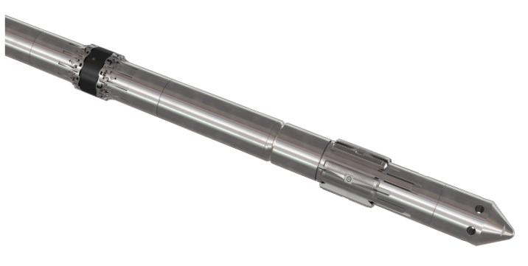

Description The patented HPHT retrievable bridge plug contains an innovative seal module which both compresses and constrains the element, enabling it to withstand extreme differential pressures. The slim design eases the deployment and retrieval through narrow wellbore restrictions, a crucial operational benefit. Efficiency is further enhanced by each plug taking just one run to set and one to retrieve. With a range of plug sizes for 2 ⅞" to 7 ⅝" casing, it's an ideal barrier solution for HPHT wells. Application The HPHT bridge plug can be used as a temporary or permanent barrier. The element and slip modules have been designed to withstand bi-directional pressure which allows the plug to be set in cross flow. Ideal for workover applications: well control barrier, packer for injection valve, fixed choke etc. It can be run as an isolation plug or a packer, and can incorporate junk extensions and/or equalizing devices.
Vendors Website Link: High Pressure High Temperature Retrievable Bridge Plug - Interwell
Interwell Electric Setting Tool (EST)
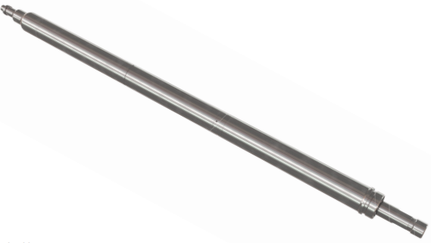
Description Available in three configurations; standard, surface powered and Bluetooth, the EST is a non-pre-pressurised, non-pyrotechnic setting tool. It’s one of the shortest setting tools available on the market to date and can be reset in-field without redress. The EST converts its internal power into a downward axial force to mechanically set Interwell or third-party products. Controlled by an Electronic Module, its processes are logged to create a setting profile for quality assurance of the set product and for health monitoring. Run on Slickline, Digital Slickline or E-Line, the EST goes through an automatic shutdown sequence after setting and at full stroke the oil is recirculated, preventing any pressure build-up. Full metal connection to the shear stud allows the EST to be jarred free if it becomes necessary. Application The EST is used for installing downhole products such as bridge plugs, packers, gauge hangers and straddles. It’s also used as the receiver in the Barrier Verification System (BVS). The Surface Powered configuration allows for real time surface display of well pressure, temperature, inclination and operational parameters such as internal pressure, voltage, current and RPM. The Bluetooth configuration enables set-up and pre-run checks at surface and log download after the job has been completed. Benefits • Long stroke • Data logging • Debris tolerant • Large output force • Resettable in-field • Reliable with extensive run record • Non-pre-pressurized, non-pyrotechnic • Independent of well pressure for operation • Can be jarred free from the plug if necessary • Simplified for use with Integrated Operations Centers (IO) Serving Every Well Rev. 2.2 Date: 3rd Mar 2022

Vendors Website Link: Electronic Setting Tool - Interwell

